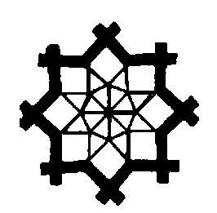
DELNET Tezpur University

Developing Library Network Tezpur

NACLIN 2016
19th National Convention on Knowledge, Library and Information Networking
October 26-28, 2016

Theme: “Smart Libraries and Inspired Librarians: Managing New Technologies,
Digital Content and Services”

Venue : Tezpur University, Tezpur, Assam

Hon’ble Shri M. Hamid Ansari, Vice-President of India has kindly consented to Inaugurate the National Convention

Exhibitors

Great reasons to be involved at the NACLIN 2016 Conference

- Showcase and demonstrate your products & services
- Create your brand awareness
- Attract new customers
- Build your network
- Communicate your product directly to end users
- Expand your market

Companies are invited to participate as Exhibitors in NACLIN 2016 organised by DELNET in collaboration with Tezpur University, Tezpur, Assam. DELNET is a major resource sharing library network in South Asia connecting more than 5500 libraries in 33 States and UTs in India and eight other countries. About 350 delegates from various parts of India and outside are expected to attend the Convention. Becoming a sponsor will give you the exposure and access to decision makers from library and information sector, knowledge sector and to explore business opportunities.

- Product Demonstration during the Sessions (15 Minutes slot) Rs. 25,000/-

- Trade Exhibit Desk/Exhibition Desk Rs. 20,000/-

- The rates for Advertisements in the NACLIN 2016 Souvenir are:

  - Full Page (on Color Paper) Rs.18,000/- (Size 23x15cm)

  - Full Page (Black & White) Rs.12,000/- (Size 23x15cm)

  - Half Page (Black & White) Rs.7,000/- (Size 11.5x15cm)

  - 2nd Cover or 3rd Cover (4 Color) Rs.25,000/- (Size 23x15cm)

  - 4th Cover (Back Cover in 4 Color) Rs.30,000/- (Size 23x15cm)

Payment: Payment should be sent through a DD/Multi-City cheque in favour of “DELNET New Delhi”
For online remittance, Kindly send a mail to sangs@delnet.ren.nic.in, sangskaul2003@yahoo.co.in for DELNET bank details.

